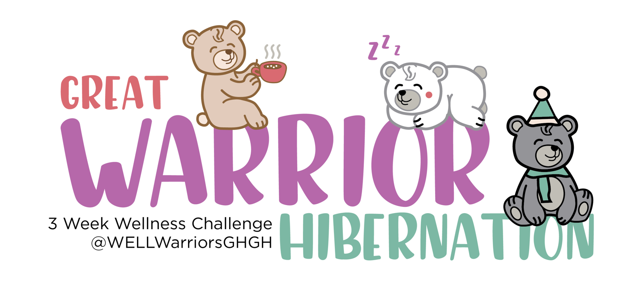

How to Play

Overview
The Great Warrior Hibernation will have one game card that will be used throughout the 3-week wellness challenge. Each square is comprised of an activity that will benefit your mental and emotional health or is a COVID safe activity.

Weekly Activities
Each week there are 5 activities to do that will help keep you entertained and safe throughout quarantine. They range from individual to virtual group activities. Stay tuned on social media for daily updates on Great Warrior Hibernation activities.

Gray Squares
On the top of the game card, there are two rows of gray squares comprised of activities to do and to avoid throughout the 3-week wellness challenge.

The activities listed in the dark gray “Don’t” squares are activities that you should avoid throughout the 3-weeks to help minimize the spread of COVID-19. If you complete an activity listed in the “Don’t” squares that is not a COVID friendly activity, you will lose 3 submission entries to the final drawing.

How to Win Prizes & Submission
There are several ways to win prizes throughout this wellness challenge. The more involved you are in participating in this challenge and follow along on social media, the more submission to drawings you will get.

For each square you complete on the game card, it will result in one submission for the drawing (up to 40 submissions possible from game card).

+1 Submission = Sign Up for Challenge
+1 Submission = Like or Comment on Social Media
+1 Submission = Post Tagging Us on Social Media
@WELLWarriorsGHGH on Facebook or @WSUHealth on all other platforms
+2 Submissions = 1 Square Completed
-3 Submissions = Completed “Don’t” Square

We are collaborating with campus and community partners for small and large prizes. Stay tuned on social media for prize details and winners.

Please submit completed game cards to: wp4prevention@winona.edu

Get Connected
Follow us on Facebook at @WELLWarriorGHGH to stay up to date with the progress of the challenge with more opportunities to win prizes!

Post your progress of your game card on social media using the hashtags #GotHealth #GotHappy #GreatWarriorHibernation
Follow our main page @WSUHealth on Facebook, Instagram, Twitter & Tik Tok.

Workbook
Resiliency Skills Training by Jessica Gifford
Reach out to wp4prevention@winona.edu to request a digital PDF copy.

How to Use Game Card
Feel free to print off the game card and fill in the squares by hand, otherwise you may use this word document to fill out the card digitally.

Copy and paste the circle below and drag it over the square on the game card that you have completed.

