How to Play

Overview
The Great Warrior Hibernation will have one game card that will be used throughout the 5-week wellness challenge. Each square is comprised of an activity that will benefit your mental and emotional health or is a COVID safe activity.

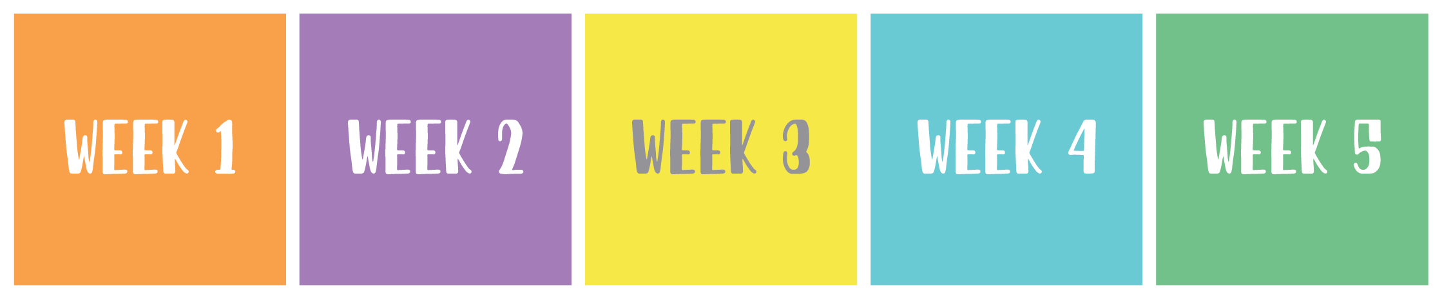

Weekly Activities
Each week there are 5 activities to do that will help keep you entertained and safe throughout the pandemic. They range from individual to virtual group activities. Stay tuned on social media for daily updates on Great Warrior Hibernation activities.

How to Win Prizes & Submission
There are several ways to win prizes throughout this wellness challenge. The more involved you are in participating in this challenge and follow along on social media, the more submission to drawings you will get.

For each square you complete on the game card, it will result in two submissions for the drawing (up to 50 submissions possible from game card).

+1 Submission = Sign Up for Challenge
+1 Submission = Like or Comment on Social Media
+2 Submission = Post Tagging Us on Social Media
@WELLWarriorsGHGH on Facebook or @WSUHealth on all other platforms
+2 Submissions = 1 Square Completed

We are collaborating with campus and community partners for small and large prizes. Stay tuned on social media for prize details and winners.

Please submit completed game cards to: wp4prevention@winona.edu

Get Connected
Follow us on Facebook at @WELLWarriorGHGH to stay up to date with the progress of the challenge with more opportunities to win prizes!

Post your progress of your game card on social media using the hashtags #GotHealth #GotHappy #GreatWarriorHibernation
Follow our main page @WSUHealth on Facebook, Instagram, Twitter & Tik Tok.

Workbook
Resiliency Skills Training by Jessica Gifford
Reach out to wp4prevention@winona.edu to request a digital PDF copy.

How to Use Game Card
Feel free to print off the game card and fill in the squares by hand, otherwise you may use this word document to fill out the card digitally.

Copy and paste the circle below and drag it over the square on the game card that you have completed.

